KUNO

AI Project and Behaviour Plan

AIE AI Assignment 2018 – 28 Jun 2018

# Abstract

This document outlines the overview of the game project, the AI systems and pathfinding algorithms to be approved and then implemented.

# Overview

The project I am putting forward for this assignment will be is a stealth based ninja game.

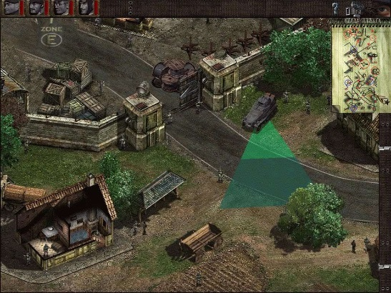The inspiration is drawn from the Commandos and Desperados series of isometric mission games, and Shinobido/Way of the Ninja style games.

The game will be set in feudal japan at the living residence of a warlord. You will be tasked at infiltrating the base, avoiding and deceiving guards where necessary, assassinating the lord and then escaping to the rendezvous point without any enemy following you back.

The game will be played on an isometric map.

The map will be ideally 2.5D isometric, but I may not have enough time to learn and implement such a system. Realistically, it will be just top down orthogonal 2D.

The player will be moved by clicking on a location on the game map like a RTS game. And like a RTS, the user can move the camera by scrolling to the sides of the screen.

There will be guards patrolling the map. They have cones of sights and will react to sounds or objects. Reactions from the enemies will be shown to the player.

The lord will mainly be staying in his room, apart from occasionally wandering out onto the porch to observe the moon reflecting off the calm pond.

**The AI behaviours will be implemented using behaviour trees.**

**All agents including the player will be using A* pathfinding to move around the map**. There may be areas of the map that are more difficult to manoeuvre across, or make more noise etc. I might set up the pathfinding algorithm so that the player avoids moving across noisy terrain.

This may all be a bit ambitious, but I want to challenge myself. I will get the basic components up and running first before attempting to implement the more difficult features. If the project deems too difficult or time consuming in certain aspects I will adjust and tone down where necessary.

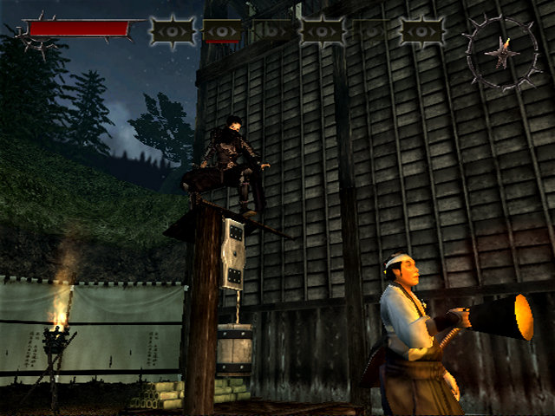

# Map

Rough prototype of the map: 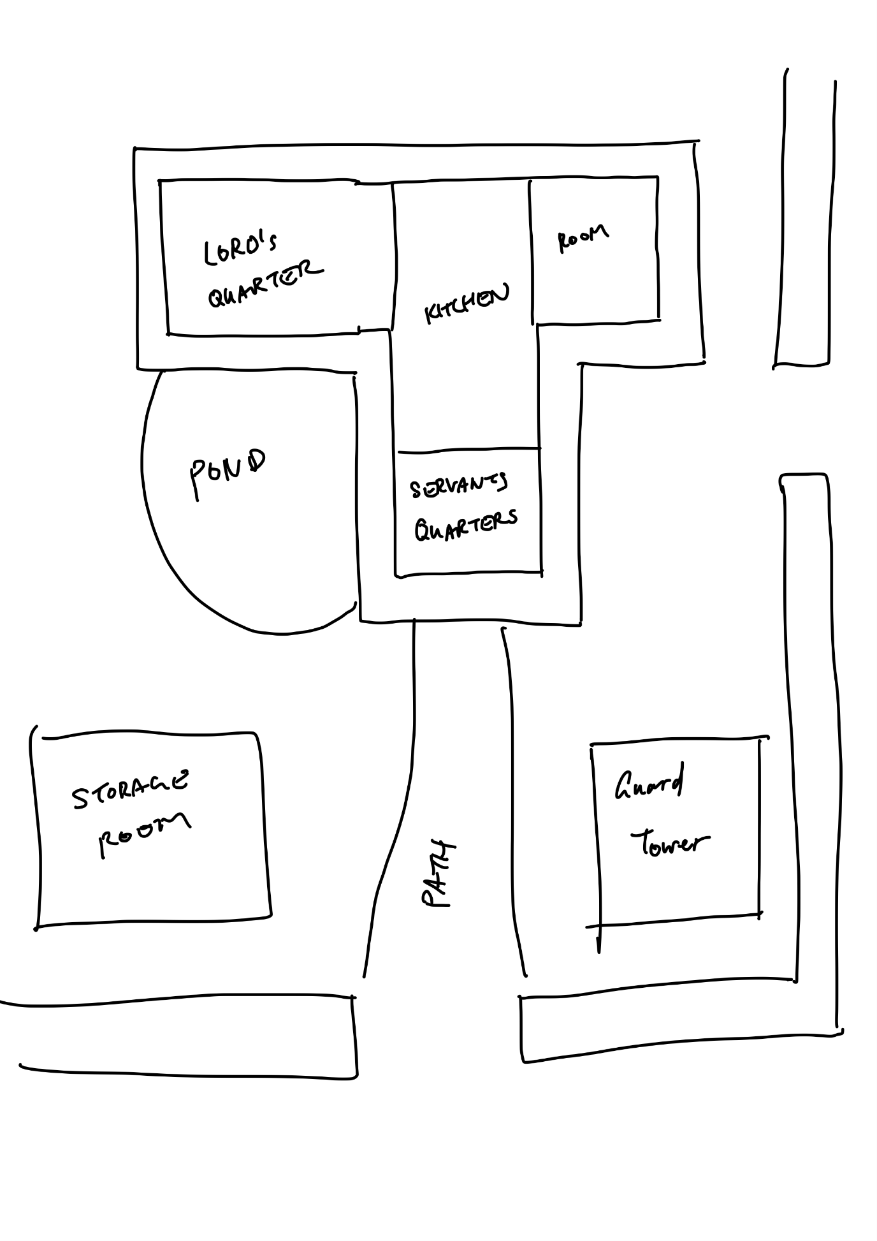

# Actors and behaviours

Okuma Yuna – Kunoichi

This actor will be controlled by the player.

To control her states, I will be implementing a hierarchical state machine. She can be in these states:

* Idle
  + Stand
  + Crouch
* Moving
  + Run
  + Walk
  + Sneak
* Attacking
  + Normal
  + Stealth
* Throw item
* Hide

Yuna shall be controlled similarly to how a unit is controlled on an RTS game; with the mouse and by selecting and clicking on the location on the map you want Yuna to move to. Double clicking can result in her running there.

Walking and running would make more noise than sneaking, which alerts nearby enemies. Yuna shall also be able to throw an item like a rock to create a diversion or distract the enemies.

Yuna’s main weapon shall be a s

Attacking an enemy from behind will trigger a stealth attack which will almost always guarantee the enemy’s death.

Enemies

Enemies will have these behaviours:

* Normal
  + Idle
  + Patrol
* Suspicious
  + Inspect
* Alert
  + Attack; if in attack range
  + Pursue; if out of attack range
  + Seek; if out of range
  + Flee; if health low

Enemies characters can include:

* Swordsman samurai
* Bowman samurai
* Servants
* Lord

# Behaviour Tree

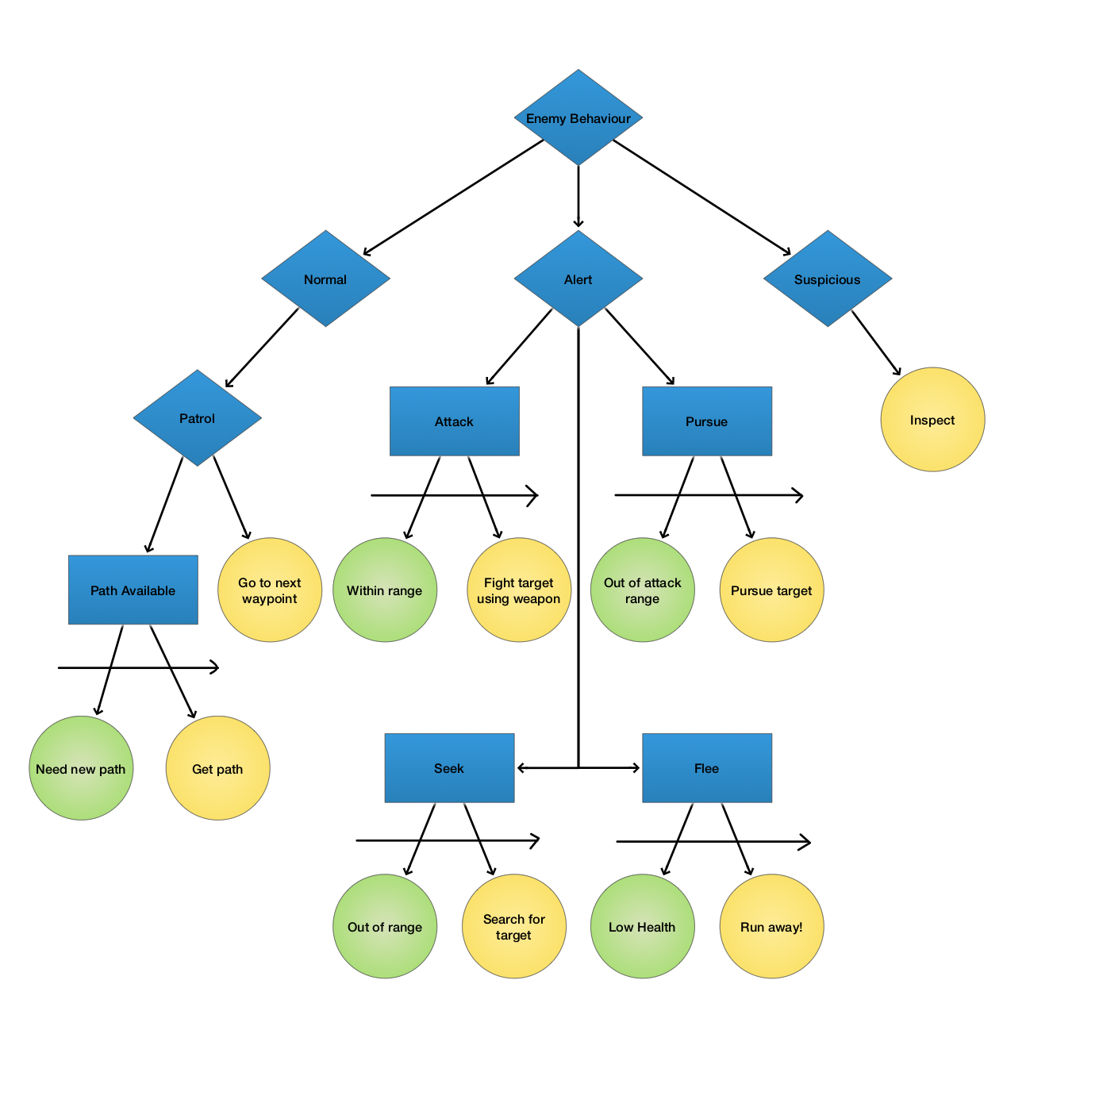Preliminary behaviour tree for the :

# REFERENCES

Kunoichi artwork from:  
<https://www.dualshockers.com/black-desert-online-gets-two-new-classes-next-week-ninja-and-kunoichi/>

Screenshots from:  
<https://www.g2play.net/category/609/commandos-behind-enemy-lines-steam-key/>

<https://www.playstation.com/en-au/games/shinobido-way-of-the-ninja-ps2/>